JOIN, RIGHT JOIN, LEFT JOIN

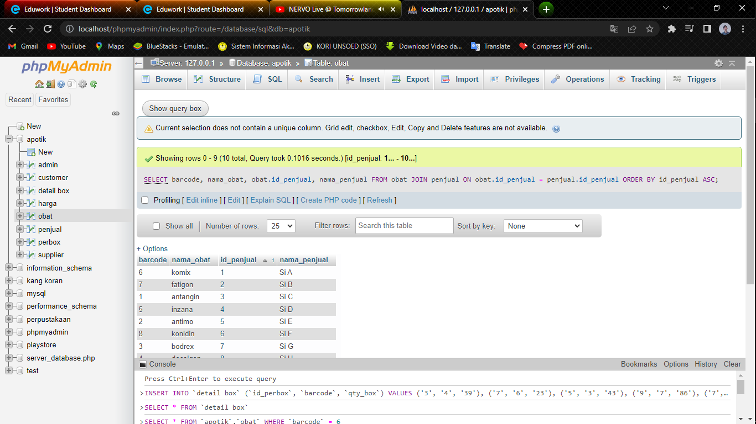

SELECT barcode, nama_obat, obat.id_penjual, nama_penjual

FROM obat

JOIN penjual ON obat.id_penjual = penjual.id_penjual

ORDER BY id_penjual ASC



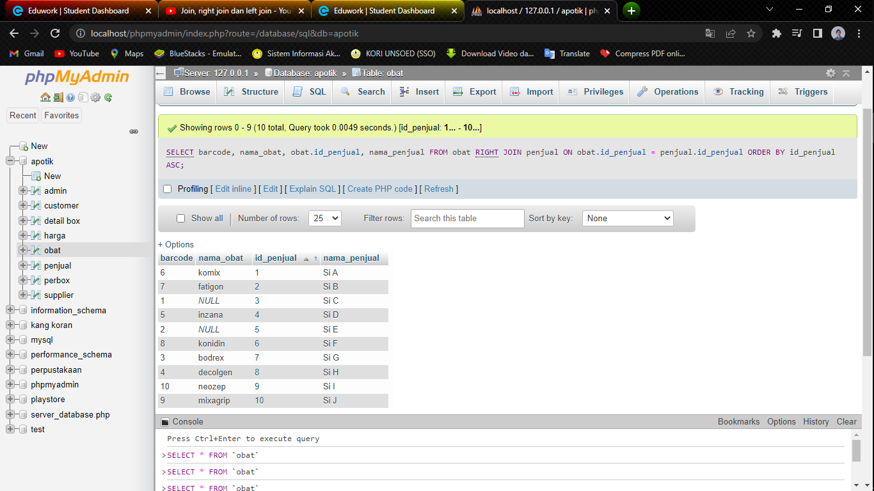

SELECT barcode, nama_obat, obat.id_penjual, nama_penjual

FROM obat

RIGHT JOIN penjual ON obat.id_penjual = penjual.id_penjual

ORDER BY id_penjual ASC

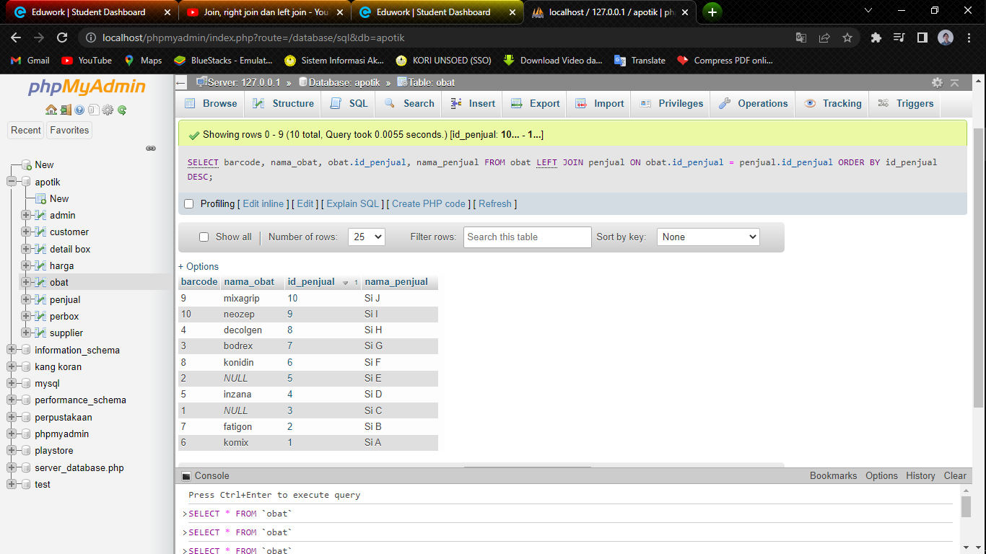

SELECT barcode, nama_obat, obat.id_penjual, nama_penjual

FROM obat

LEFT JOIN penjual ON obat.id_penjual = penjual.id_penjual

ORDER BY id_penjual DESC



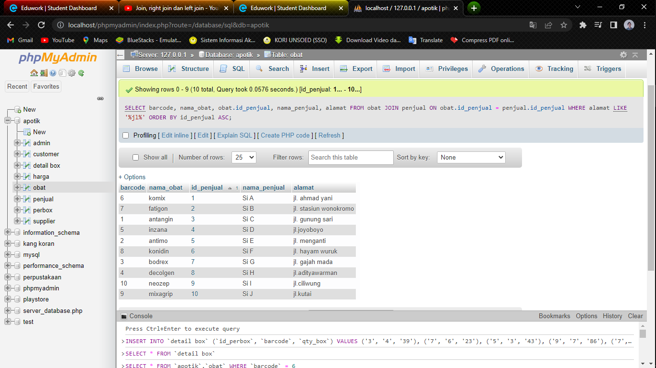

SELECT barcode, nama_obat, obat.id_penjual, nama_penjual, alamat

FROM obat JOIN penjual ON obat.id_penjual = penjual.id_penjual

WHERE alamat LIKE ‘%jl%’

ORDER BY id_penjual ASC

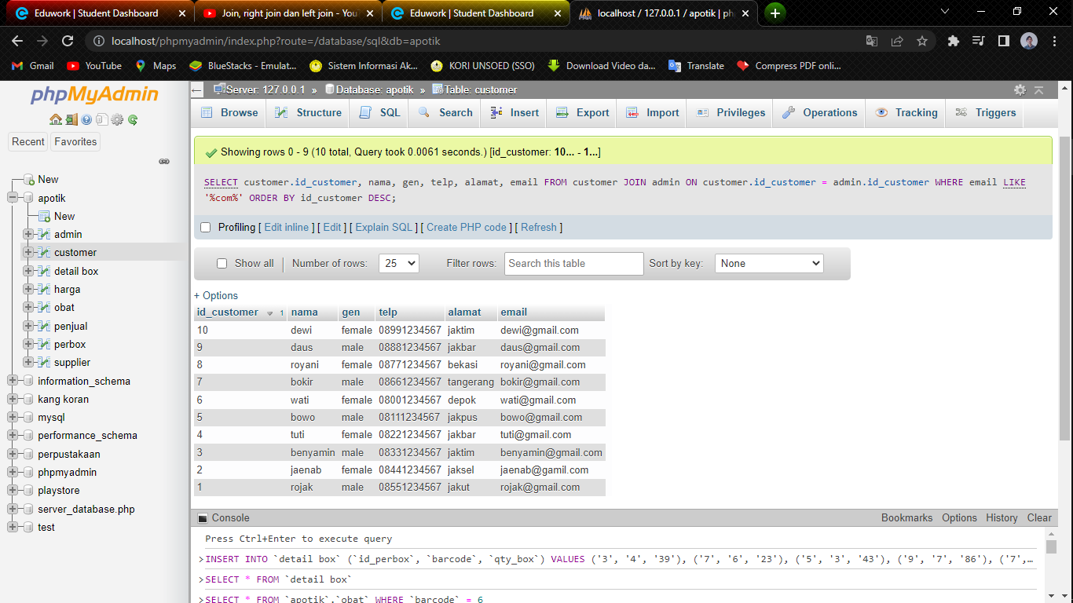

SELECT customer.id_customer, nama, gen, telp, alamat, email

FROM customer JOIN admin ON customer.id_customer = admin.id_customer

WHERE email LIKE ‘%com%’

ORDER BY id_customer DESC